

**Capstone Project Concept Note and Implementation Plan**

**Cutting-edge Computer Vision Technique for Brain Tumor Diagnosis**

**By :Jalil Akbarzai**

**1. Project Overview**

This project focuses on developing an advanced brain tumor detection system using the YOLOv11 model, aligning with the Sustainable Development Goal (SDG) 3: Good Health and Well-being. Brain tumors remain a critical health issue due to delayed detection and limited access to automated diagnostic tools. This project aims to provide a fast, accurate, and computationally efficient solution, improving diagnostic precision and enabling timely treatment to reduce mortality rates.

**2. Objectives**

* Develop a robust, real-time brain tumor detection model using YOLOv11.
* Improve detection accuracy and reduce computational complexity for clinical applicability.
* Bridge the gap between research and clinical application through a lightweight and deployable system.

**3. Background**

The complexity of manual tumor diagnosis in medical imaging necessitates automated solutions. Existing models, such as CNNs and ensemble approaches, offer high accuracy but face limitations like computational overhead and biased datasets. Leveraging YOLOv11’s advanced capabilities provides a solution that is both effective and suitable for real-time use in clinical environments.

**4. Methodology**

The project uses YOLOv11 for real-time brain tumor detection due to its cutting-edge architecture. The model will be trained on labeled MRI datasets sourced from platforms like Roboflow and Google Datasets. The process involves:

* Data preprocessing and augmentation to address class imbalance.
* Training and fine-tuning YOLOv11 for accurate tumor classification.
* Evaluating the model’s performance using metrics like precision, recall, and F1-score.

**5. Architecture Design Diagram**

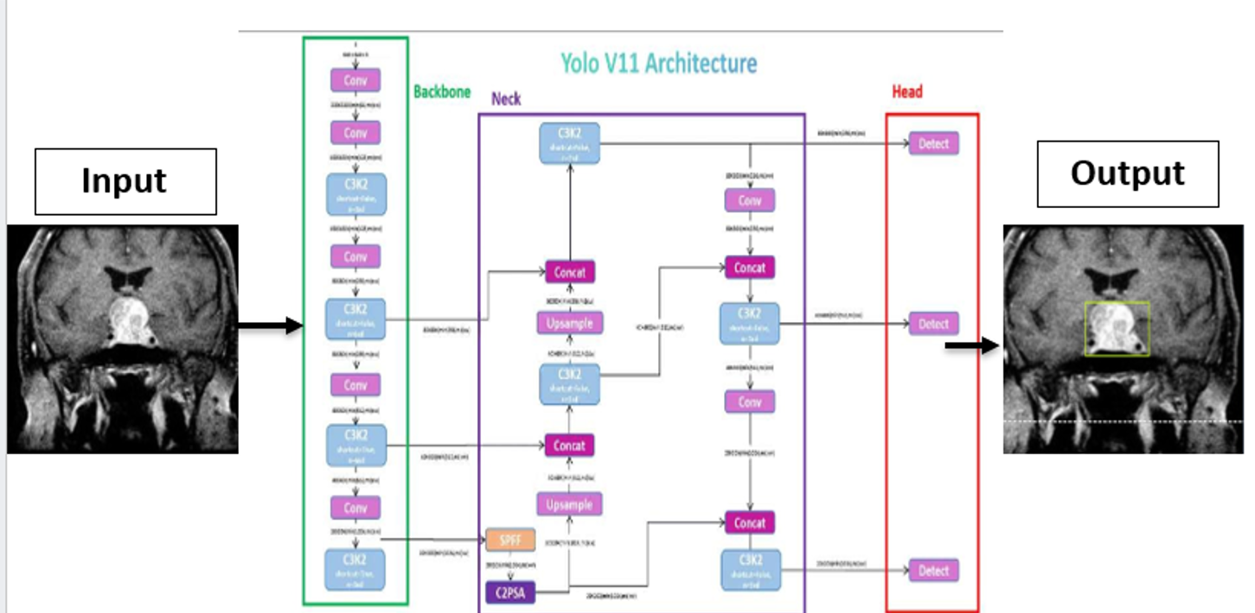

*Diagram Description:*

* **Input Layer**: Processes MRI scans.
* **Feature Extraction**: YOLOv11 backbone extracts features.
* **Detection Layer**: Outputs bounding boxes with tumor classifications.

**6. Data Sources**

MRI data will be obtained from Roboflow and Google Datasets, which provide labeled and diverse datasets for training and evaluation. Preprocessing steps include resizing, normalization, and augmentation to ensure uniformity and improve robustness.

**7. Literature Review**

Advancements in artificial intelligence (AI) and deep learning (DL) have significantly transformed brain tumor diagnosis, achieving high accuracy and efficiency in medical imaging. Several studies highlight these advancements. Mahmud et al. [1] proposed a convolutional neural network (CNN) model for brain tumor detection and classification using magnetic resonance imaging (MRI), outperforming models like ResNet-50, VGG16, and Inception V3, achieving 93.3% accuracy and an AUC of 98.43%. Grampurohit et al. [2] demonstrated the efficacy of CNN and VGG-16 architectures in detecting tumors in MRI images, emphasizing the potential for precise automated diagnosis. Archana et al. [3] introduced a hybrid approach combining U-Net for image segmentation and Bagging Ensemble with K-Nearest Neighbor (BKNN) for classification, achieving 97.7% accuracy and addressing challenges like manual segmentation. Additionally, Hammad et al. [4] developed a lightweight CNN model tailored for real-time applications, achieving up to 99.48% accuracy in binary classification, while addressing issues such as computational costs and data biases. These studies collectively demonstrate the potential of DL models to enhance tumor detection, reduce system complexity, and improve real-world usability.

**Implementation Plan**

**1. Technology Stack**

* **Programming Languages**: Python
* **Libraries**: PyTorch, TensorFlow, OpenCV
* **Frameworks**: YOLOv11
* **Web application**: using Hugging Face
* **Hardware**: NVIDIA GPUs for training

**3. Milestones**

* Completion of dataset preprocessing.
* Achieving 95% accuracy on the test set.
* Successful deployment of the YOLOv11 model for real-time testing.

**4. Challenges and Mitigations**

* **Data Quality**: Addressed through robust preprocessing and augmentation.
* **Model Performance**: Fine-tuning hyperparameters to optimize results.
* **Computational Constraints**: Utilizing cloud services like Google Colab Pro.

**5. Ethical Considerations**

* Ensuring data privacy through anonymized datasets.
* Addressing bias by using diverse and representative datasets.
* Assessing the model’s potential impact on healthcare delivery.

**References**

[1]Mahmud, Md Ishtyaq, Muntasir Mamun, and Ahmed Abdelgawad. "A deep analysis of brain tumor detection from mr images using deep learning networks." *Algorithms* 16.4 (2023): 176.

[2]Grampurohit, Sneha, et al. "Brain tumor detection using deep learning models." *2020 IEEE India Council International Subsections Conference (INDISCON)*. IEEE, 2020.

[3] Archana, K. V., and G. Komarasamy. "A novel deep learning-based brain tumor detection using the Bagging ensemble with K-nearest neighbor." *Journal of Intelligent Systems* 32.1 (2023): 20220206.

[4] Hammad, Mohamed, et al. "Efficient brain tumor detection with lightweight end-to-end deep learning model." *Cancers* 15.10 (2023): 2837.